Gabriel Barnard
18th of February 2026
CS-320-19695-M01 Software Test, Automation QA 2026 C-1 (Jan - Mar)
Summary and Reflections Report
Throughout the Software Development Life Cycle (SDLC), carefully utilizing thorough tests that verify the code meets its specified requirements guarantees a high-quality, robust, optimized, and highly functional end product. In this essay, I will defend the alignment of my tests to software requirements, defend the effectiveness of my tests by reflecting on code coverage, describe how I ensured my code was technically sound, describe how I ensured my code was efficient, reflect on the testing techniques I used, reflect on the testing techniques I didn’t use, explain the uses and implication of the techniques I did and didn’t use, reflect on the importance of employing caution, assess the importance of limiting bias, and evaluate the importance of being disciplined when developing code.
To what extent was your approach aligned to the software requirements? Support your claims with specific evidence.
First, my testing approach of utilizing thorough tests that test requirements in multiple ways aligned with the software requirements to a large extent. This can be seen in the Module Three Milestone description, which states that the Contact.java file “shall have a required firstName String field that cannot be longer than 10 characters.” To fulfill the testing requirement of firstName not being longer than 10 characters, in lines 45-55, in the ContactTest.java file, I use a test called firstNameTooLong that uses the Assertions.assertThrows method to check what happens when a contact object is created with a firstName variable that is over 10 characters and what happens when a contact object’s firstName is set to something less than 10 characters but then set to over 10 characters (See screenshot 1 below this paragraph). This specific example clearly demonstrates how my testing approach aligns with the software requirements by showing adherence to the criteria of firstName needing to be less than 10 characters by testing the requirement under two conditions: an object created with a firstName that is too long, and an object modified to have a firstName that is too long. Additionally, the Module Four Milestone description states, when referring to the Task object, “The description field shall not be null.” To meet the requirement of the description variable not being null, in lines 81-91 of my TaskTest.java file, I created a test that verifies whether an IllegalArgumentException is thrown when the Description variable is initialized as null when creating a new Task object, and when it is manually set to null through its setter method (see screenshot 2 below). This test demonstrates how my testing approach aligns with the software requirements. It does this by using the Assertions.assertThrows method to verify that an exception is thrown when the description variable is initialized to null or manually set to null. Lastly, the Module Five Milestone description states that “The appointment service shall be able to add appointments with a unique appointment ID.” To ensure that I met this requirement, I created a JUnit test in the AppointmentServiceTest.java file. This test uses the assertTrue method to confirm that the addAppointments method works correctly when using regular expected values (See screenshot 3). Moreover, I also created another JUnit test that uses the Assertions.assertThrows method to determine if the addAppointment service throws an exception when trying to add a method with a duplicate ID (See screenshot 4). This example clearly shows how my unit testing approach aligns with the software requirement that the addAppointment service method should be able to add an appointment with a Unique ID. It does this by testing the method with regular and duplicate values.
Screenshot 1:
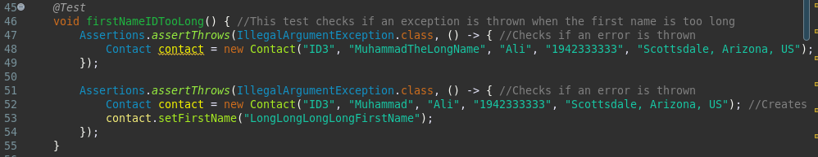
Screenshot 2:
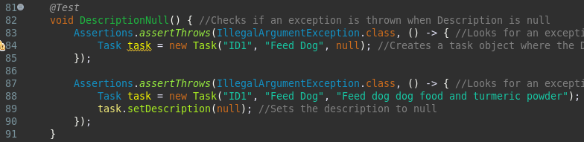
Screenshot 3:
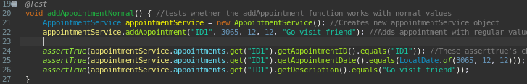
Screenshot 4:
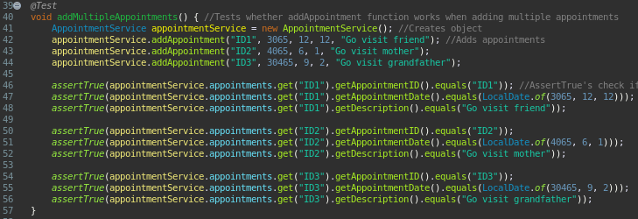
Defend the overall quality of your JUnit tests. In other words, how do you know your JUnit tests were effective based on the coverage percentage?
Second, my JUnit tests were high-quality because they were effective on the basis of test coverage percentage by attaining 96.6% test coverage; in essence, the tests executed 96.6% of the code in the main package (see screenshot 1 below this paragraph). This is considered a healthy test coverage percentage (Zyaparova, 2025), and if only looking at code coverage, it is generally considered sufficient to release an application in production. Code coverage is important because it provides a quantitative measure of how much of an application’s code, behavior, or functionality is tested (James, 2025). In my project, the tests achieved a high coverage percentage by using clear tests that distinctly fulfilled the requirements described in the Module Three Milestone description, and by using those tests as an opportunity to review and improve issues in my code. Moreover, the JUnit tests were high-quality due to their thoroughness; in fact, despite there being only 19 requirements across the entire project, I created 43 separate tests - over two times the required amount. This gives each a high degree of comprehensiveness. An example of how I achieved this in Module Three is shown by ContactTest.java’s NumberTooShort test (lines 117-127, see screenshot 2 below this paragraph). This test has two separate Assertions.assertThrows statements to test the Number variable’s shortness requirement in different ways. Rather than, for example, having one test for the Number variable that aims to test the Number under both the too long, too short, and non-digit tests at the same time, without using multiple assert statements for each test. Additionally, I also created high-quality tests in Milestone Two. For example, in lines 45-46 of the TaskTest.java (see screenshot 3 below), I created a test that uses Assertions.assertThrows to check if an exception is thrown when the Task object’s Name variable is over 20 characters in length. Similar to the aforementioned test, in this test, I check if the variable meets its requirements in two ways: one where the Name variable is set to over 20 characters upon the creation of the Task object, and another where the Name variable is manually set to over 20 characters after the creation of the object. This demonstrates high-quality tests, as testing the variable in two ways, rather than testing it in only one, enables a greater range of opportunity to identify defects in the code. Lastly, I also created high-quality tests in Milestone Three. This can be seen in lines 39-57 of the AppointmentServiceTest.java file (see Screenshot 4 below), where I use the assertTrue method to test whether the addAppointment method works correctly when adding multiple tasks at once. This demonstrates high test quality in two primary ways. First of all, the mere existence of a test that checks whether the addAppointment method works well under multiple tests is an indicator of high quality. This is because it shows that the addAppointment method is tested in a variety of ways, rather than just with a generic test that checks whether the addAppointment method works fine when adding a single appointment (see screenshot 5 below). Second, this test demonstrates high quality by adding three distinct appointments, each with its own unique values, rather than just two duplicate appointments. This is because the test is an add multiple appointments test. Technically, this could have been fulfilled with just two duplicate appointments, but I instead chose to add three distinct appointments to create an extra vector from which to identify defects in the program.
Screenshot 1:
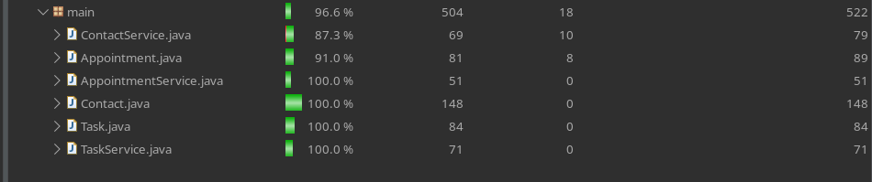
Screenshot 2:
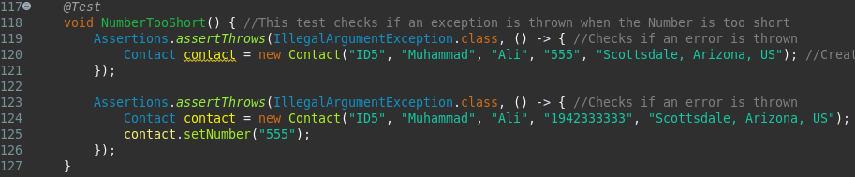
Screenshot 3:
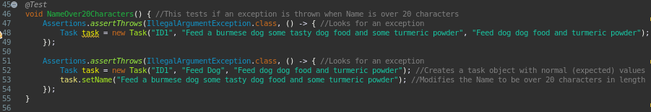
Screenshot 4:
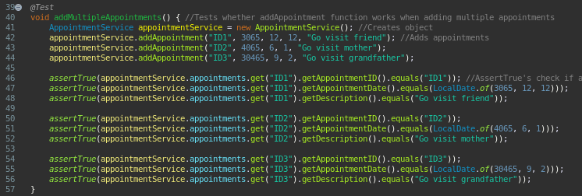
Screenshot 5:
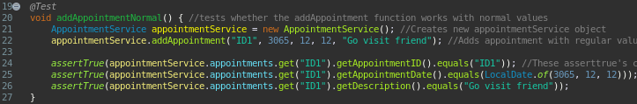
How did you ensure that your code was technically sound? Cite specific lines of code from your tests to illustrate.
Third, I ensured my code was technically sound - i.e., code that is free of faults and correctly performs its required functions - by utilizing Eclipse’s static code analysis tool to identify and correct errors in my code and by using thorough unit tests to ensure that my code correctly performs its specified requirements. An example of when I used Eclipse to fix errors in my code is in line 11 of the ContactService.java file. In this line, I create a HashMap called “contacts” (see Screenshot 1 below this paragraph). However, during development, I forgot to include the parentheses after the second pair of angle brackets. Eclipse informed me of this by displaying a red squiggly line below the code. Upon seeing this, I promptly mended my mistake, enabling my code to remain fault-free. An example of when I used unit tests to ensure that my code correctly performed its specified requirements was when, in lines 17-27 of the ContactServiceTest.java file, I used a test called “addContactsTest” to ensure that the addContacts method worked properly with its expected values (see screenshot 2 below this paragraph). In this test, I used the assertTrue method to verify that each of the parameters of the addContact method had correctly assigned the contactID and the default values of the remaining parameters.
Screenshot 1:
Screenshot 2:
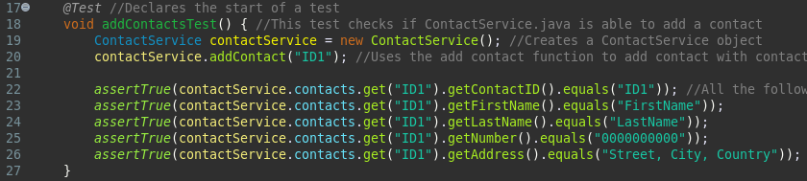
How did you ensure that your code was efficient? Cite specific lines of code from your tests to illustrate.
Fourth, I ensured my code was efficient by minimizing the amount of redundant code and by ensuring that all my methods and classes were in the shortest feasible time and space complexity. Efficient code refers to code that executes quickly, consumes minimal memory and other resources, and adheres to best coding practices (Amazing Algorithms, n.d.). For example, I minimized the amount of redundant code in lines 30-40 of the ContactService.java file (see screenshot 1 below this paragraph); rather than creating four separate methods for modifying a contact, I combined them all into one method. This makes the code more efficient but doesn’t affect the user experience. If a user wants to change a specific part of the contact, the parameters the user doesn’t want to change can be set to the object’s pre-existing variables, while only displaying the parameter the user wants to change. Analogously, in lines 17-32 of the Contact.java file (see screenshot 2 below this paragraph), I improved the code’s efficiency by using the OR operator (||) to check each variable for two criteria at the same time; rather than, for example, creating two separate if statements for each of the criteria. This makes the code more efficient without making it any more confusing. In fact, using fewer if statements, in this specific scenario, makes the code more readable. Lastly, I improved the time efficiency of the AppointmentService.java file in line 12 by utilizing a HashMap (see Screenshot 3) rather than a traditional array or vector. This is time-efficient because a HashMap works in O(1) time complexity, with a worst-case scenario of O(n) time complexity. In contrast, in this specific scenario, an array or vector array would use, at best, O(n) time complexity (Ahmed, 2024).
Screenshot 1:
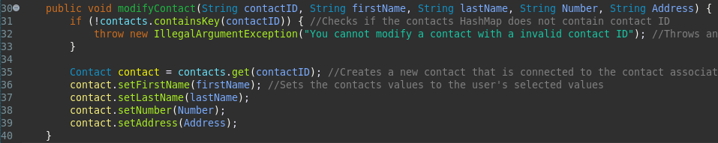
Screenshot 2:
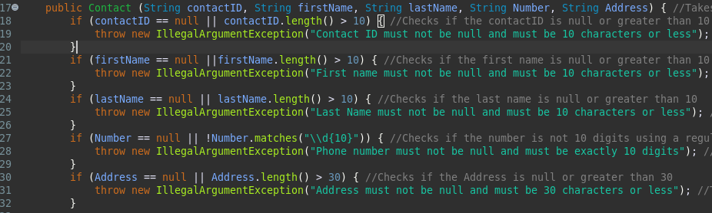
Screenshot 3:
What were the software testing techniques that you employed in this project? Describe their characteristics using specific details.
Fifth, during each milestone, I employed unit and static testing. Unit testing involves testing individual parts of code independently to verify each part fulfills its specified requirements (Hambling, 2019). In the modules, I achieved this with JUnit tests, which verified that each of my methods met the criteria in the assignment description. For example, during the first milestone, in lines 27-34 of the ContactTest.java file, I produced a JUnit test that checked whether an exception was thrown when a contact’s ID was over ten characters (see screenshot 1 below). Static testing refers to testing code before it is executed (Hambling, 2019). This can usually be done through manual code review and an IDE’s static code analysis tool; the latter of which I focused on significantly more during the milestones. For instance, in Milestone Two, in lines 16-30 of the Task.java file, when creating the constructor, I accidentally misspelled the class’s name (see Screenshot 2 below). The IDE’s static code analysis rapidly informed me of this by providing a red underline beneath the name, allowing me to correct my error.
Screenshot 1:
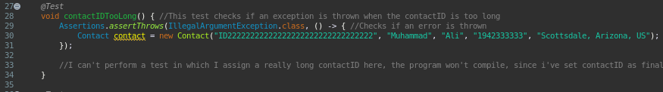
Screenshot 2 (the functional constructor):
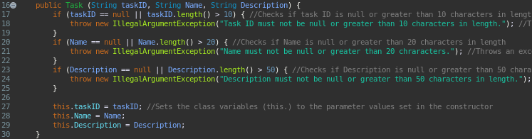
What are the other software testing techniques that you did not use for this project? Describe their characteristics using specific details.
Sixth, during the milestones, I did not use performance testing or compatibility testing. Performance testing refers to testing whether software applications retain optimal performance under high workloads. The types of performance testing are load testing, scalability testing, volume testing, endurance testing, soak testing, spike testing, and stress testing (GeeksforGeeks, 2025). A prime example of how I could use performance testing is by seeing if Milestone Two’s AppointmentService.java’s HashMap performs well under large amounts of appointments - this is known as volume testing. Compatibility testing means testing if an application’s functions perform correctly and meet their requirements across different operating systems, devices, and environments (GeeksforGeeks, 2025). For instance, I could apply this to the previous milestones by testing whether the Java applications' tests still pass when running on Android, Linux, macOS, iOS, and Windows 11.
For each of the techniques you discussed, explain the practical uses and implications for different software development projects and situations.
Seventh, for different software development projects and situations, the aforementioned testing methods of unit testing, static testing, performance testing, and compatibility testing have many practical uses and implications. The practical use of unit testing is automation of tests; the implication is saving time and a higher-quality end product. For example, if I’m building a web application in Java, unit tests can verify that no part of the website is vulnerable to Cross-Site Scripting (XSS), ensuring a higher quality end product. The practical use of static testing is earlier resolution of issues; the implication is saving time during dynamic testing and reducing costs, since solving a fault costs more the later it is found. For instance, while building an MP3 music player in Swift, static testing can be used to correct syntax errors before running the code, saving time and money. The practical use of performance testing is to verify whether an app can handle large workloads; the implication is a higher-quality end product by enabling developers to fix performance-related issues. To illustrate, if I am working on a messaging app in Rust, I could use performance testing by verifying if the code works fine when processing thousands of messages at once. If it doesn’t, I would now have the chance to fix the issue, thereby resulting in a higher-quality end product. The practical use of compatibility testing is guaranteeing an application has cross-platform, cross-device, and cross-environment compatibility; the implication is a higher-quality end product. An example of this is using compatibility testing on a C++ calculator app by ensuring that it works across multiple devices, such as a TV, phone, laptop, and Kindle, thus guaranteeing a higher-quality end product.
Assess the mindset that you adopted working on this project. In acting as a software tester, to what extent did you employ caution? Why was it important to appreciate the complexity and interrelationships of the code you were testing? Provide specific examples to illustrate your claims.
Eight, I adopted a testing mindset when working on this project. To approach a project with a testing mindset means considering how each aspect of a program can break, rather than just focusing on how it should work (Josifoski, 2025). One critical aspect of this mindset is caution, which is why I employed caution to a large extent in acting as a software tester. Approaching testing with caution is vital because testing haphazardly can result in perfunctory tests of the software, which in turn cause the software to retain defects and fail to meet requirements. For example, in 2010, the car company Toyota failed to be cautious during testing of its anti-lock braking software. This resulted in a significant issue slipping past them. Specifically, the brakes of their vehicles experienced significant delays between pressing the brakes and actually braking. This resulted in numerous crashes worldwide (Bushell, 2025). An example of when I exercised a testing mindset and caution in my own code is in the AppointmentServiceTest.java file, in lines 59-100 (see screenshot 1 below). In these lines, I created three separate tests for the deleteAppointment method: one that tests deleting an appointment normally, one that tests deleting multiple appointments, and one that tests deleting a non-existent appointment. Strictly speaking, the only necessary test is the first one, which tests deleting an appointment normally. However, by exercising a testing mindset and caution, I chose to create two additional tests. This enabled me to test the AppointmentService.java file from more angles, improving the program’s quality by increasing the likelihood of catching defects. Moreover, it is important that I appreciate the complexity and interrelationships of code when testing because it involves acknowledging how even a small problem can wreak havoc on an entire program. This awareness prompts a cautious approach towards creating tests, enabling me to focus on building tests that thoroughly test every aspect of the program. To illustrate the complexity and interrelationships of code, in line 12 of my project’s AppointmentService.java file, I created a HashMap to store appointments (see screenshot 2 below). If I had initialized this HashMap incorrectly, then the addAppointment (see screenshot 3 below) and deleteAppointment functions wouldn’t have worked at all. Fortunately, I was able to easily verify that the HashMap worked correctly in the AppointmentServiceTest.java file by testing it through the methods of the AppointmentService class.
Screenshot 1:
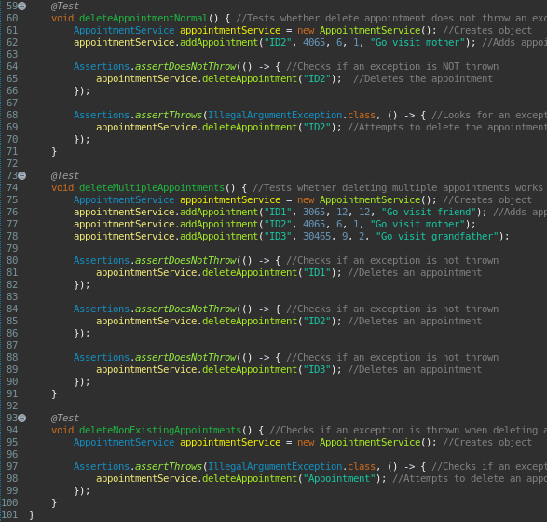
Screenshot 2:
Screenshot 3:
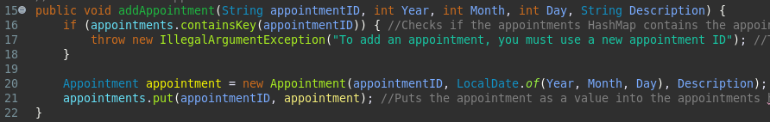
Assess the ways you tried to limit bias in your review of the code. On the software developer side, can you imagine that bias would be a concern if you were responsible for testing your own code? Provide specific examples to illustrate your claims.
Ninth, limiting bias when testing code is essential because code that is tested in a biased manner may contain defects that weren’t sufficiently tested, resulting in a low-quality end product. Bias when testing code refers to the unintentional skewing of results due to subjective opinions, preferences, or assumptions of the tester. This results in innacurate, incomplete, or unreliable test outcomes (Gunashree, 2024). I tried to limit bias in my review of the code by ensuring that I viewed my code through a more objective lens, such as by analysing code coverage and by ensuring that I created unit tests that tested every aspect of the program. For example, the overall code coverage for all the .java files in my main package is 96.6% (see screenshot 1 below), which serves as a clear, objective metric for how much of my code was actually tested in the JUnit tests. On the software developer side, I can imagine that bias would be a concern if I were responsible for testing my own code. This is because I want the code that I produce to succeed, and as a consequence of that, I may be inclined to shine a more favorable light upon it. For instance, in my ContactTest.java file, because of my bias towards my own code, I initially limited myself to a few rudimentary tests that tested all the variables once (see screenshot 2 below), rather than giving each of the variables its own test. Later, I modified this and added unit tests specifically targeting each variable, enabling me to have a greater chance of identifying defects in the code.
Screenshot 1: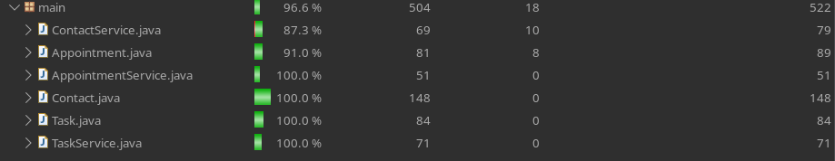
Screenshot 2 (A rudimentary test that checks all variables at once, rather than giving each its own test):
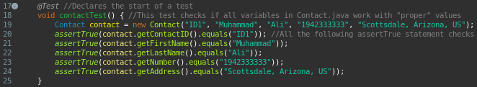
Finally, evaluate the importance of being disciplined in your commitment to quality as a software engineering professional. Why is it important not to cut corners when it comes to writing or testing code? How do you plan to avoid technical debt as a practitioner in the field? Provide specific examples to illustrate your claims.
Last, but not least, I must be disciplined in my commitment to quality as a software engineering professional, whether by not cutting corners or by preventing technical debt. To be disciplined in my commitment to quality as a software engineering professional means ensuring that all software I produce works reliably, performs well, meets requirements, and makes users happy (6Sigma, 2024). It is important not to cut corners when writing or testing code, because doing so will ultimately result in low-quality code. Consequently, low-quality code leads to a worse-performing, more difficult-to-maintain, less functional end product. Additionally, producing a low-quality end product would tarnish my reputation as a software engineering professional. The gravity of these effects can be demonstrated by the disaster that was NASA’s Mars Climate Orbiter. NASA’s Mars Climate Orbiter was a space probe designed to study Mars from orbit and serve as a communication relay for the Mars Polar Lander and deep space probes. However, during the development of its software, some developers used English Units, while others used metric units; NASA cut corners by not correctly specifying to the developers which they should use and by not performing sufficient testing. This resulted in the climate orbiter burning up in Mars’ atmosphere (NASA, n.d.), demonstrating the harsh consequences of cutting corners when writing or testing code. I plan to avoid technical debt by verifying that my code meets requirements set during the SDLC by utilizing thorough tests, such as unit, static, dynamic, performance, and compatibility tests. Technical debt refers to organizations accruing high future costs from taking shortcuts or making suboptimal decisions (Mucci, n.d.). To illustrate, in my project, I avoided technical debt in the TaskService.java file by employing multiple unit tests in a separate TaskServiceTest.java file (see screenshot below for an example) to verify that my code was fully functional and aligned with software requirements.
Screenshot:
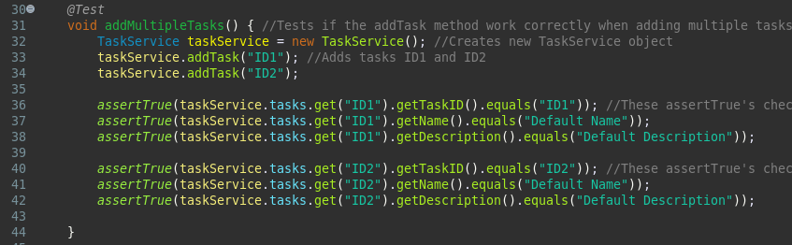

In conclusion, performing thorough testing throughout the Software Development Life Cycle (SDLC) is essential to creating a high-quality, robust, optimized, and highly functional end-product. My testing approach was aligned to software requirements to a large extent. My JUnit tests were high-quality because they were effective based on coverage percentage by achieving 96.6% test coverage, and because they provided a high degree of thoroughness. I ensured my code was technically sound by utilizing unit tests and Eclipse’s static code analysis tool. I ensured my code was efficient by reducing redundant lines of code and by ensuring all methods and functions I created minimized time and space complexity. The software testing techniques that I employed in this project are unit testing and static testing. Some other software testing techniques that I didn’t use in this project are performance testing and compatibility testing. The practical uses of unit testing, static testing, performance testing, and compatibility testing are numerous; they include automating tests, saving time and money, fixing performance issues, and enabling cross-platform, cross-device, and cross-environment compatibility. The mindset adopted while working on this project was a testing mindset, and in doing so, I employed caution to a large extent. It is important to appreciate the complexity and interrelationships of the code I was testing to ensure that I understood how even a tiny problem could destroy the rest of the program. I tried to limit bias in my review of the code by viewing it from a more objective lens, such as by looking at test coverage and by utilizing unit tests. On the software developer side, I can imagine how bias would be a concern if I were responsible for testing my own code; I want to make my own code succeed, and because of that, I am biased in its favor. It is important to be disciplined in my commitment to quality as a software engineering professional because a lack of quality leads to worse-performing, less maintainable, and less usable code. It is important not to cut corners when writing or testing code, because doing so can have significant negative repercussions, such as malfunctioning systems in a Toyota car resulting in many car crashes. Lastly, I plan to avoid technical debt when working as a practitioner in the field by verifying that my code meets all specified requirements and is highly functional through unit, static, dynamic, and compatibility tests.

Sources are on the next page.

Sources
- James. (2025, May 6). Defining Good Test Coverage with Unit Testing and End-to-End Testing. Medium. https://medium.com/@james.genqe/defining-good-test-coverage-with-unit-testing-and-end-to-end-testing-c954b6458684
- Zyaparova, P. (2025, September 26). Is 70%, 80%, 90%, or 100% Code Coverage Good Enough? Qt. https://www.qt.io/quality-assurance/blog/is-70-80-90-or-100-code-coverage-good-enough
- Amazing Algorithms. (n.d.). Code Efficiency. https://amazingalgorithms.com/definitions/code-efficiency/
- Ahmed, A. (2024, January 15). Why is a HashMap faster than Array? Devcript. https://www.devcript.com/why-a-hashmap-is-faster-than-array/
- Hambling, B. (2019, July 26). Software Testing: An ISTQB-BCS Certified Tester Foundation Guide - 4th Edition. BCS.
- GeeksforGeeks. (2025, July 20). Performance Testing - Software Testing. https://www.geeksforgeeks.org/software-testing/performance-testing-software-testing/
- GeeksforGeeks. (2025, July 23). Compatibility Testing in Software Engineering. https://www.geeksforgeeks.org/software-engineering/compatibility-testing-in-software-engineering/
- Josifoski, V. (2025, April 17). Thinking Like a QA: How to Build a Tester’s Mindset. QAlogy. https://qalogy.com/thinking-like-a-qa-how-to-build-a-testers-mindset/
- Bushell, C. (2025, July 7). Real-Life Software Testing Horror Stories. eTestware. https://www.etestware.com/post/real-life-software-testing-horror-stories
- Gunashree, R. S. (2024, September 14). Guide to Understanding and Managing Tester Bias in Software Testing. Devzery. https://www.devzery.com/post/guide-to-understanding-and-managing-tester-bias-in-software-testing
- 6Sigma. (2024, November 14). The Guide to Software Quality: Definition, Metrics, and Best Practices. https://www.6sigma.us/six-sigma-in-focus/software-quality/
- NASA. (n.d.) Mars Climate Orbiter. https://science.nasa.gov/mission/mars-climate-orbiter/
- Mucci, T. (n.d.). What is technical debt?. IBM. https://www.ibm.com/think/topics/technical-debt

